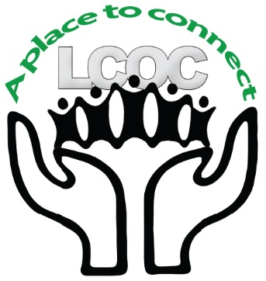

LUTHERAN CHURCH OF THE COVENANT
Gather…Grow…Give…Go
Office Coordinator
Position Description

Lutheran Church of the Covenant is a vibrant faith community with the overall vision of knowing, living, and telling the story of God’s love for all. This position is a key team member and leader of the faith community. This position primarily supports the pastor and church leadership. There will be extensive interaction with congregational members and others contacting the church office. The Office Coordinator is expected to give leadership in the areas of office management and communications.

SKILLS AND ABILITIES:
- Enjoy working in a congregation located in a multicultural community
- Familiarity with general office procedures either through formal training or equivalent experience
- Outstanding oral and editing skills and an eye for detail
- Exceptional computer skills particularly with Microsoft products (Word, PowerPoint, Excel, etc.) and Google services
- Familiarity with social media, especially Facebook, Constant Contact, Twitter, Instagram, and YouTube
- Solid organizational skills and good interpersonal skills
- Maturity to demonstrate a high degree of confidentiality, grace, and compassion
- Proven ability to exercise judgement and make decisions independently
- Able to maintain a positive and supportive attitude under stress
- Able to work with minimal supervision
- Fluency in Spanish a plus yet not required

CREDENTIALS:
- A college degree or equivalent experience in Office Administration, Business Management, Communications, or a related field is preferred.
- Personal or professional experience in a faith-based organization

REPORTS TO: Pastor

RESPONSIBILITIES:
Desktop Publishing Responsibilities:
- Coordinate, create, edit, format and print weekly, funeral, wedding, baptism, and special occasion bulletins, Annual Report, congregational directory, newsletter, and other printing jobs as needed
- Create PowerPoint for worship services and weekly PowerPoint for sharing upcoming events
Social Media Responsibilities
- Lead social media presence by drafting, editing, and posting social media content
- Update and modify website as needed
- Post sermon audio and video to YouTube

Communications Responsibilities:
- Coordinate, create, edit and format mass emails to Congregation and others
- Support team leads in the creation of flyers and advertisement of events
- Coordinate, create, edit, and format weekly E-News
- Communicate regularly with worship participants
Database:
- Maintain membership and volunteer data in Servant Keeper
- Maintain church records – i.e. communion, new members, transfers and pastoral rites such as baptisms, confirmation, funerals and weddings
Building Use and Schedules
- Maintain the LCOC master calendar.
- Schedule building usage according to church guidelines for church groups and outside entities
- Assist in preparing contracts for outside building usage
- Maintain inventory of church keys
Financial Responsibilities:
- Coordinate with LCOC Treasurer for payment of accounts payable as needed
- Secure all received funds according to church procedures
- Handle benevolence requests according to guidelines i.e., person enters office asking for help for food, bus fare, etc.
General Responsibilities:
- Welcome all visitors and callers in a respectful manner
- Answer basic inquiries
- Answer and route phone calls
- Answer and route emails
- Sort and distribute email
- Research issues as required
- Order approved Supplies and flowers (office, cleaning, or kitchen supplies etc.)
- Assist teams with office supply/equipment contracts
- Maintain paper files including contract and legal documents
- Recruit and train community members to help with general duties
- Other duties as assigned

HOURS: Monday – Friday – 25-28 hours/week, willingness to attend occasional evening and weekend meetings

STARTING SALARY RANGE: $18-$20 to commensurate with experience

CONTINUING EDUCATION:
- Attend seminars or other professional development as appropriate

TO APPLY: Email resume, cover letter, and names and contact information for three professional references to resume4office@lcocdalecity.org.

